Notes For Nerds

1. The imported headscan STL file MUST intersect with the origin, if not then the script will exhibit strange behavior around Step 3. For a guide on how to adjust a floating model, see:

https://brandon3d.com/how-to-move-object-origin-point-blender-3d/

I have been using the “Set Geometry to Origin” function which moves the entire object down to the origin point, centering it as well. This has worked to solve the issue up until this point.

2. The PROPORTIONAL DIMENSION operation is for 2 very important functions:
A. To adjust an object size that may have been inadvertently re-scaled by moving the decimal in either direction. This is likely due to program hopping and is easily corrected.

B. To add extra space to account for padding between the user’s head and the inside of the helmet. For example, assume you want 0.25” (6.35mm > 6.4mm) padding inside the helmet, and that your current model is 100mm in the X axis. You would do the following:

X WIDTH + (DESIRED PADDING SIZE x 2) = NEW VALUE

In this case, 100 + (6.4x2) = 112.8mm

I would like to have a more user friendly setup for this that simply asks for input and then shows the padding in the viewer window but I haven’t come up with a simple way to do that, any help on this is appreciated. As of now the SHOW/HIDE HEAD function will incorporate the padding calculations and be ever-so-slightly oversized.

3. At Step 2, when the hinge mechanism is applied to the helmet, there are a couple of quirks:
A. If the connector piece is too deep and intersects the helmet, then the parts will fuse and the split operation in Step 3 will fail. I would like to make this issue disappear completely and simply have the intersected material be subtracted in a boolean operation but I can’t think of a simple way to do it. Once again, I am asking for some Python pros to look into it.

B. Even if the operations in Step 2 (and subsequently Step 3) are a success, there is still a glaring flaw that I would like to see an automated solution for. The image on the next page shows the present results on the left next to the desired outcome on the right. The flattened area depicted on the right was done manually but I would like the process to be fully automated, I would like some Python devs to take a crack at this problem and see if a simple solution can be found.

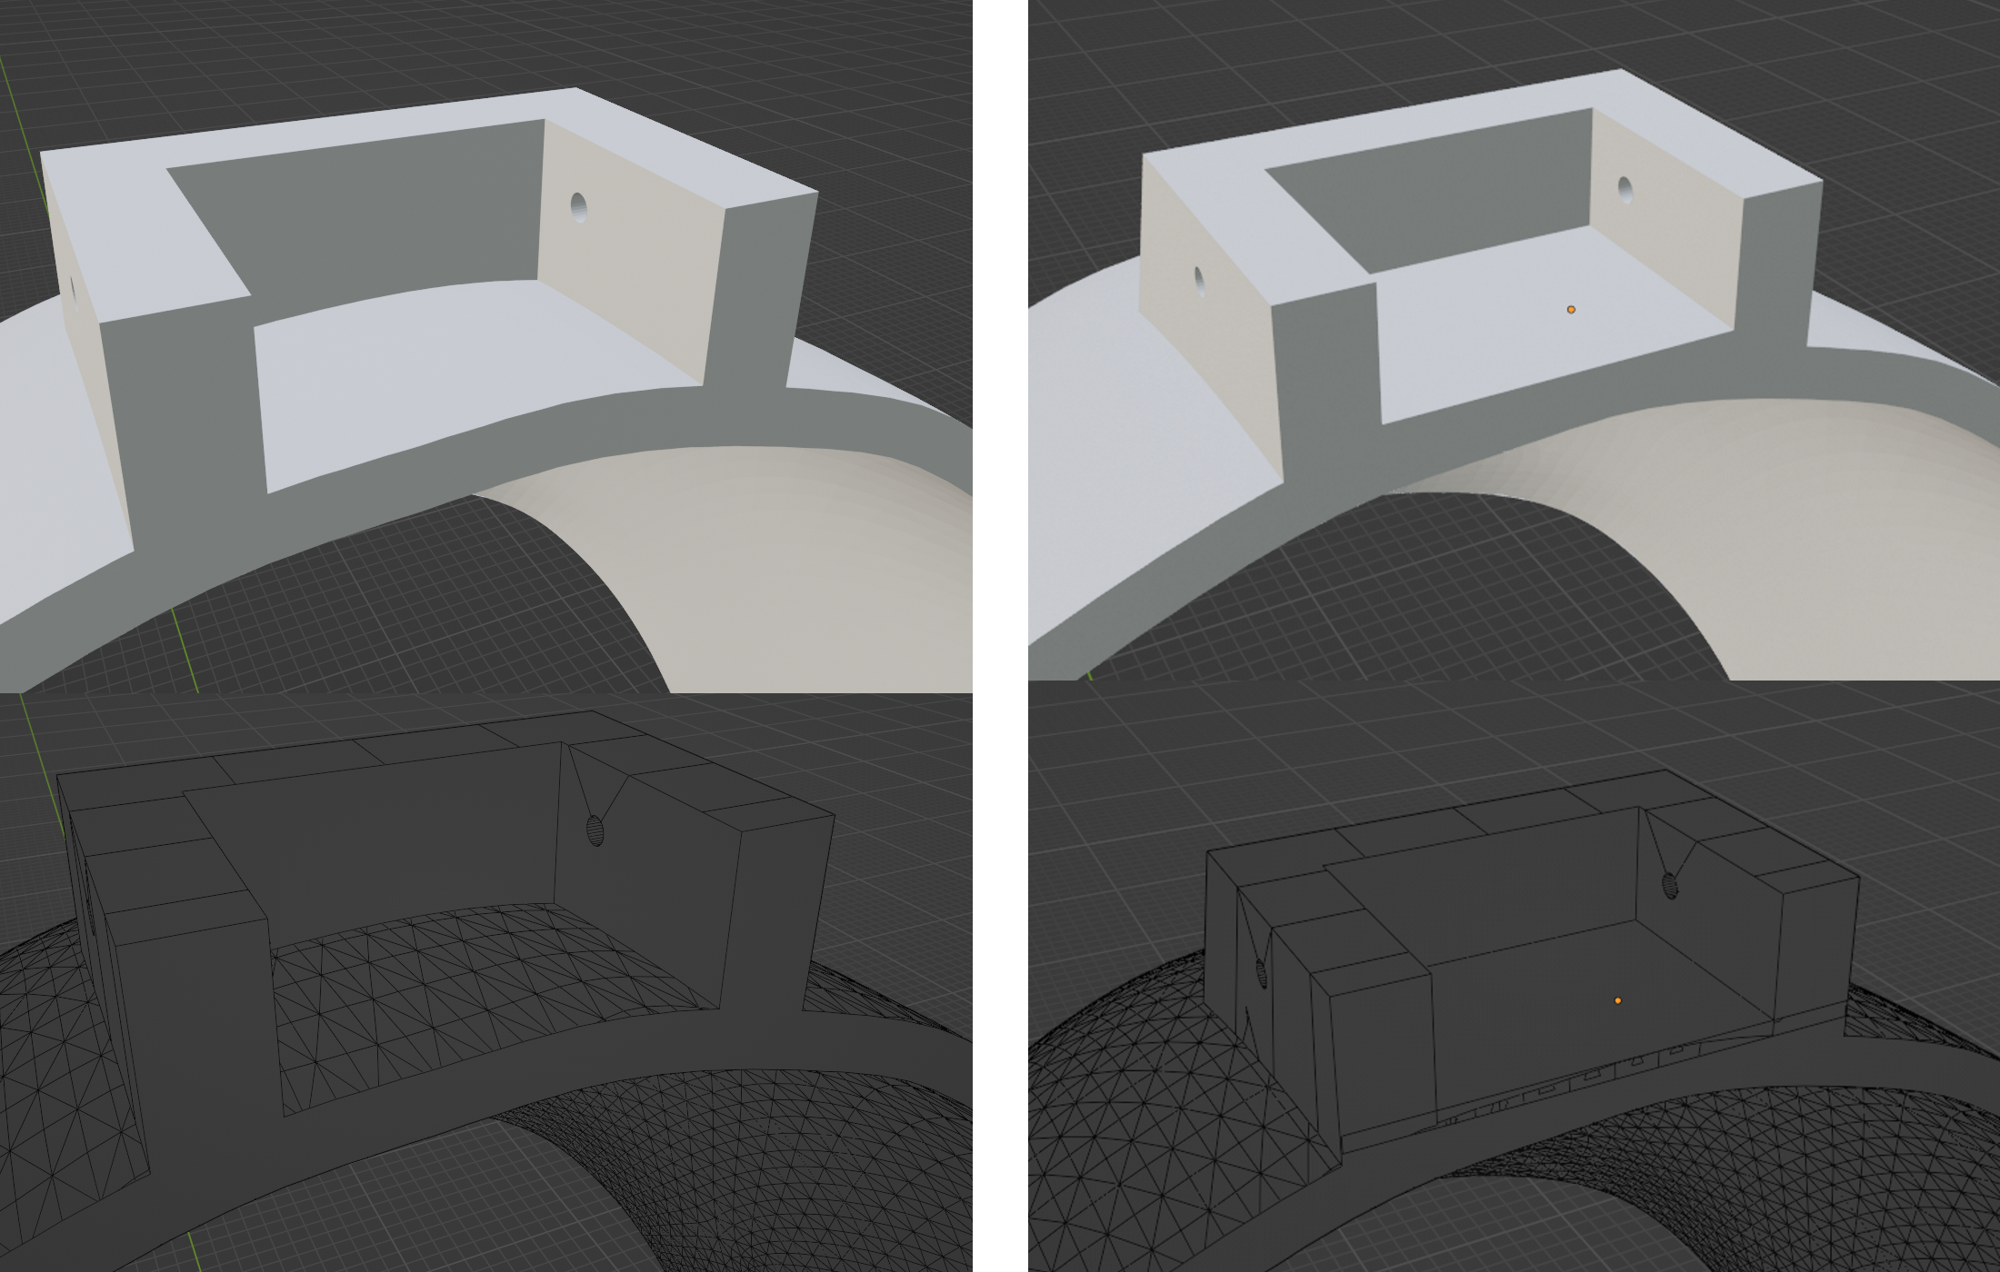
Left shows the present curved outcome Right shows the desired outcome

